V2 23 Aug 2019


Data quality approach

What checks do we make and when?

- Quality assure digitised data
Activity
All paper and/or electronic records are extracted from the local authority and converted into a digital format.

What is checked?
- All relevant text data is accurately and completely captured from source
- Pre-existing digital extents are accurately associated with the correct text record
- Geometries that are created are in the correct position and occupy the correct extent

Outcome
A complete digital record (text and spatial extent) has been captured for each charge, which accurately reflects the source information.

2. Formative assessment

Activity
Local authority submits all local land charges (LLC) records, including those that have been through digitisation, to enable a holistic assessment of all their data.

What is checked?
- Each record has all mandatory items
- The position of geometries accurately reflects the land/property description
- The data adheres to overarching rules or requirements

Outcome
Where data is incomplete, inconsistent or inaccurate this ‘early warning’ assessment enables us to work with you to close the gap, often by applying agreed business rules during transformation.
3. Final quality assurance sign-off

Activity
All LLC records are transformed into a single format and structure before being migrated to our LLC Register.

What is checked?
- All LLC records have been captured and accurately transformed to align with the LLC data specification
- No errors or irregularities have been entered during transformation
- The data achieves at least the minimum acceptable quality level against a range of technical criteria

Outcome
Each digital record is complete (text and spatial extent), accurate and has been transformed into a standard format that can be stored, accessed and maintained in our LLC Register.
1
2
3

Extract (digital)
Engagement Co-ordinate
Quality assurance gate 1
Transform and load
Local authority (LA)
HM Land Registry (HMLR) LLC Register
Map data
Paper/ electronic records
Digital records
Analyse
Digitise
Final quality assurance sign-off
Formative assessment
Export
Serve notice
Profile data

Extract (scan)
Quality assurance output

How do we check the data?

- Acceptable quality levels (AQL) are defined against key technical criteria.
- We use a standard set of questions called ‘quality measures’ to evaluate each data set to ensure a consistent approach.
- We use automated programs where possible to validate the entirety of each data set.
- We use statistically valid manual sampling where this is not possible.

We check the spatial extent for:
- Multiple charges registered against identical land descriptions where the spatial extents do not fall within +/- 50m of each other
- Charges that include a full postcode and the spatial extent falls +/-50m outside of the postcode area
- Listed building charges against Natural England data
- A statistically valid sample of all charges not considered above.

Quality theme | Quality criteria | Example quality measure | AQL
Completeness | Omission | Does each submitted LLC contain all mandatory attributes? | 100%
Completeness | Commission | Are there any LLCs with additional or replicated data attributes? | 95%
Thematic accuracy | Classification | Have charge types and charge sub-categories been allocated correctly? | 99%
Logical consistency | Conceptual (adherence to Digitisation Practice Guide (DPG) or other agreed Local Business Rules) | Have all mandatory and conditional items been replicated accurately from the source?  Have tree preservation order spatial extents been captured as per 3.3.4 DPG?  Have originating authorities been captured in single agreed format? | 95%
Logical consistency | Domain (adherence to wider rules) | Have UPRN and structured address been matched correctly? | 97%
Logical consistency | Topological consistency | Have all spatial extents been captured without loops or self-intersects? | 95%
Positional accuracy | Relative position | Is there an acceptable relationship between the land description and the spatial extent? | 99%
Temporal | Consistency | Have all dates been captured in the prescribed YYYY/MM/DD format? | 95%
Temporal | Validity | Do expiry dates come after registered date? | 95%

Examples

Temporal
An illustration of invalid creation and registration dates. We use agreed rules to correct these automatically.

Identifier | Creation date | Registration date | Local authority
61068 | Null | 31/10/2067 | X
645123 | 14/02/2088 | 14/02/2008 | Y
121212 | 13/04/2026 | 10/06/2016 | Z
999231 | 02/07/2025 | 06/08/2015 | Z

HMLR global business rule defines ‘what’ | LA agree “how” via local business rule
Registration date cannot be a date in the future. | Registration date 2068, 2067 should be 2008, 2007.
Registration date must be equal to, or later than, the creation date. | We refer charges with a registration date before the creation date back to you.

Logical consistency
Where the same data point is described in different ways, we use agreed rules for uniform representation to correct these automatically.

Original representations of Historic England in LA data | HMLR business rules defines ‘what’ | HMLR and LA agree ‘how’ to describe via a local business rule
Historic England | ‘Each instance of a unique Originating Authority name must be captured as the single standard representation.’ | Historic England
English Heritage |  | Historic England
Historic England  0370 333 0607 |  | Historic England
English Heritage  1 Waterhouse Square  138-142 Holborn  London EC1N 2ST |  | Historic England
Historic England  Cannon Bridge House  25 Dowgate Hill  London EC4R 2YA |  | Historic England

Split spatial extents
Approximately 30% of all local land charges are multiple charges registered against a single description. We expect geospatial extents sharing the same description to be in the same place. Our quality checks focus on charges with the same address with spatial extents more than 50m apart.
Four spatial extents registered against 21 Old Hall Street
Two spatial extents in the true position

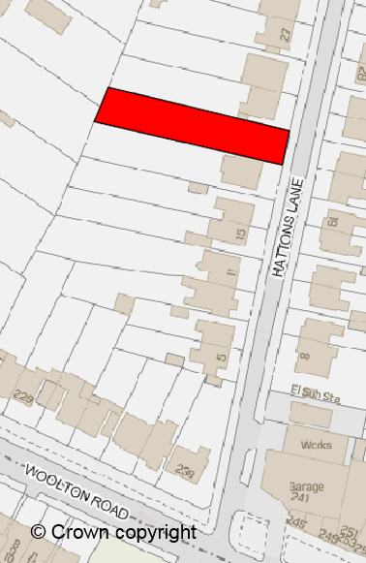
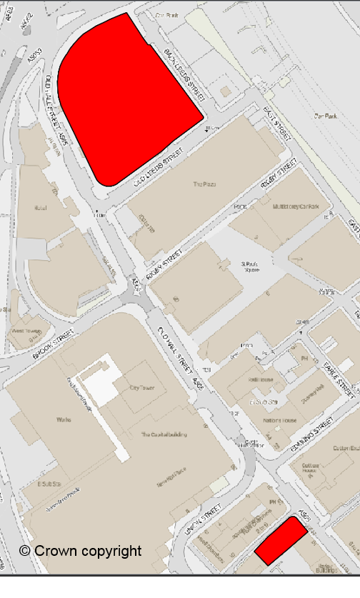

One against 122 Old Hall St (350m from address)

One against property in Hatton’s Lane (6.5km from address)

© Crown copyright and database right 2019 Ordnance Survey licence no. 100026316. Use of address and mapping data (including the link between the address and its location) is subject to Ordnance Survey licence terms and conditions.
Postcode areas
We use an automated process to compare spatial extents with the full valid postcode area. Our quality checks focus on charges where the spatial extent is more than 50m from the postcode area. The illustration shows 12 Ladyfield with an incorrect postcode and more than 50m away from the postcode area so we flag this as an anomaly.

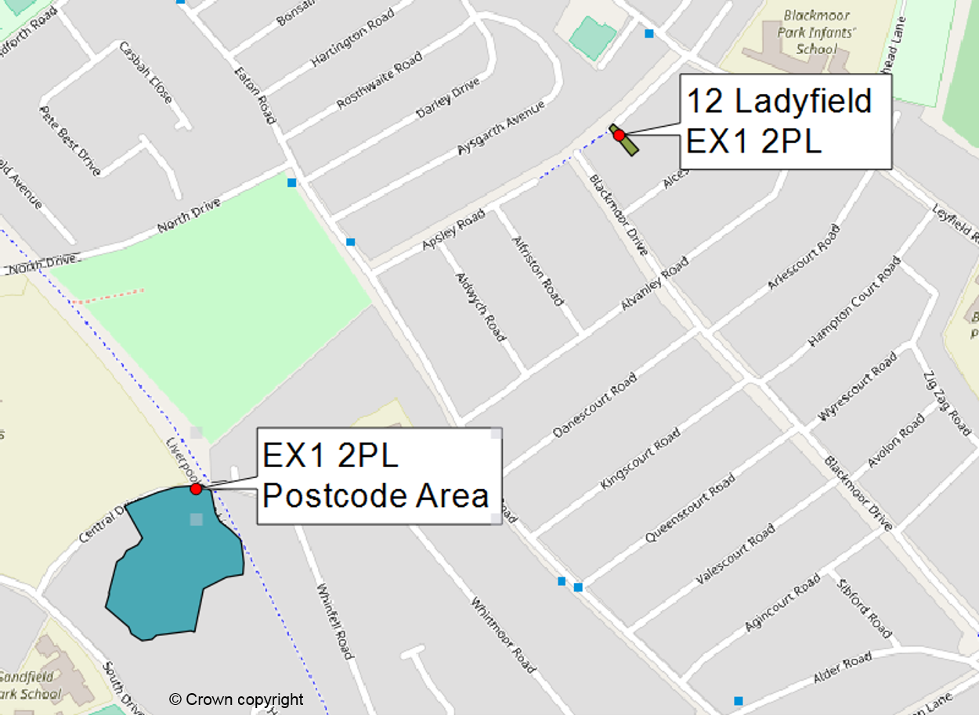
© Crown copyright and database right 2019 Ordnance Survey licence no. 100026316. Use of address and mapping data (including the link between the address and its location) is subject to Ordnance Survey licence terms and conditions.

Random sampling
In addition to sample-checking, we select a number of charges at random The example shows that the geographic property description and point do not correspond. We highlight this as an anomaly for you to consider.
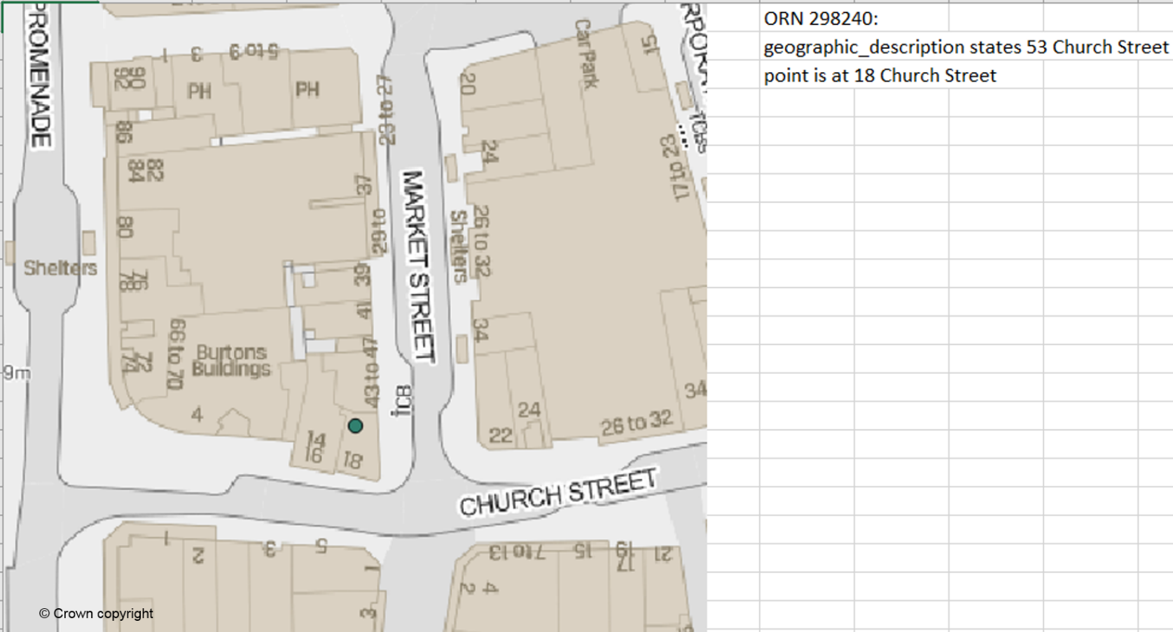

Listed buildings
We check a sample of charges against information on the Historic England website and flag anomalies for you to consider.

© Crown copyright and database right 2019 Ordnance Survey licence no. 100026316. Use of address and mapping data (including the link between the address and its location) is subject to Ordnance Survey licence terms and conditions.

Further information

Video: Creating a national LLC Register
Video: How to add, update or cancel charges on the LLC Register using the Maintain service
Video: Searching for local land charges on GOV.UK
Practice Guide 79: Local Land Charges
Infrastructure Act 2015
LLC Act 1975 (as amended)
LLC Rules 2018
LLC Fees (England) Rules 2018
New burdens information
Read our pre-migration guide for more detailed information on preparing your data.

Any questions?
llcproject@landregistry.gov.uk

